**AKGEC/IAP/FM/02**

**AJAY KUMAR GARG ENGINEERING COLLEGE, GHAZIABAD**

**DEPARTMENT OF CIVIL ENGINEERING**

**SESSIONAL TEST-2**

**Course: B.Tech Semester: V**

**Session: 2017- 2018 Section: CE-1, CE-2**

**Subject: Structural Analysis- 2 Sub. Code: NCE-504 Max Marks: 50 Time: 2 hours**

**Section A**

1. Attempt **all** parts. (2*5 = 10)
2. Define ‘flexibility coefficient aij’ and ‘stiffness coefficient kij­’.
3. Draw I.L.D for horizontal thrust of two hinged arch.
4. What is the horizontal thrust developed in a semicircular arch of radius R subjected to a UDL of W/ unit length over the entire span? Assuming EI to be constant throughout.
5. State Muller Breslau principle.
6. What do you mean by stiffness matrix?

**Section B**

2. Attempt **all** parts. (5 * 5 = 25)

**(a)** A two hinged parabolic arch of span L and rise h carries a uniformly distributed load of w per unit run over the whole span. Find horizontal thrust at each support.

**(b)** Determine the influence line for RA of the continuous beam given below. Compute the ordinates at every 1m interval.

Capture.PNG

**(c)** Generate stiffness matrix for the beam with reference to the coordinates shown in fig. below-

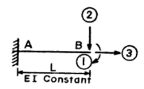

**(d)** Draw Influence line diagrams for bending moment at any section, radial shear and normal thrust at any given section for a typical two hinged symmetrical parabolic arch.

**(e)** Generate flexibility matrix for the beam with reference to the coordinates shown in fig. below-

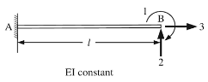

**Section -C**

3. Attempt **all** parts. (7.5 *2 = 15)

**(a)** For and two hinged parabolic arch as shown in figure determine the Horizontal thrust, Maximum positive and negative moments, Shear force and normal thrust at 10m from the right support

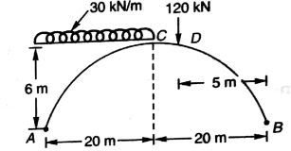

**(b)** Analyze the continuous beam shown below by stiffness matrix method and draw BMD. Take EI as constant.

